|  |  |  |  |  |
| --- | --- | --- | --- | --- |
| **Health History Questionnaire:**  **🞏 Initial 🞏 Annual** | | | | |
| Name_____________________________________________________ | | | Date of birth_____________________________ | |
| Address______________________________________________________________________________________________ | | | | |
| Local phone number____________________________ | | Alternative phone number________________________ | | |
|  | | | | |
| **Special Communication Needs: Requires Updating Annually** | | | | |
| **Language preference:** | | | |
| **If 'yes' to any of the questions below, how can we assist?** | | | |
| **Visual impairment 🞏 Yes 🞏 No** | | | |
| **Hearing impairment 🞏 Yes 🞏 No** | **Cognitive impairment 🞏 Yes 🞏 No** | | |
| **Speech impairment 🞏 Yes 🞏 No** | **Sensory impairment 🞏 Yes 🞏 No** | | |
|  | **Other:** | | |

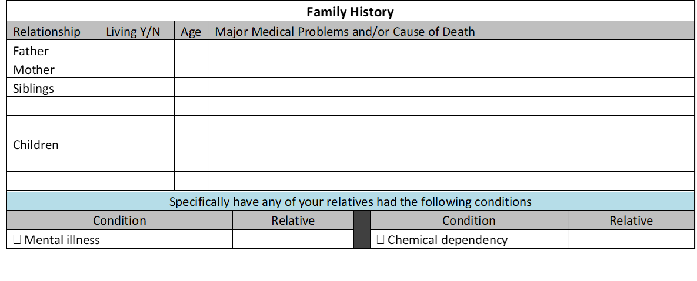

Opioid dependency

|  |  |  |  |  |  |
| --- | --- | --- | --- | --- | --- |
| **Personal Health History** | | |  | **Previous Surgical Procedures** | |
| **No Change Since Previous Year 🞏** | | | **No Change Since Previous Year 🞏** | |
| **Please check past or current problems or conditions** | | | **Please check if you have had any of the following** | |
| **Condition** |  | **Condition** | **Procedure** | **Year** |
| **🞏 Hypertension** | **🞏 Seizures** | **🞏 Heart surgery** |  |
| **🞏 High cholesterol** | **🞏 Headaches** | **🞏 Carotid artery surgery** |  |
| **🞏 Diabetes** | **🞏 Stroke** | **🞏 Vascular surgery / stent** |  |
| **🞏 Heart attack or angina** | **🞏 Prostate problem** | **🞏 Abdominal aneurysm repair** |  |
| **🞏 Irregular heart rhythm** | **🞏 Breast problem** | **🞏 Hysterectomy** |  |
| **🞏 Congestive heart failure** | **🞏 Urinary tract infections** | **🞏 Gallbladder removed** |  |
| **🞏 Asthma** | **🞏 Osteoarthritis** | **🞏 Appendix removed** |  |
| **🞏 Emphysema or chronic bronchitis** | **🞏 Cancer (Please list type)** | **🞏 Tonsillectomy** |  |
| **🞏 Pneumonia** | **🞏 Thyroid problem** | **🞏 Joint replacement** |  |
| **🞏 Gastroesophageal reflux disease** | **🞏 Bleeding disorder** | **🞏 Breast cancer surgery** |  |
| **🞏 Stomach ulcer** | **🞏 Addiction Issues** | **🞏 Prostate cancer surgery** |  |
| **🞏 Kidney problems** | **🞏 Depression or anxiety** | **🞏 Hernia** |  |
| **🞏 Liver disease/hepatitis** | **🞏 Mental Illness** | **🞏 Pacemaker** |  |
| **🞏 Colon cancer** | **🞏 Other (please describe)** | **🞏 Other (please describe)** |  |
| **🞏 Bowel/digestive problem** |  |  |  |  |  |



|  |  |
| --- | --- |
| Please list any new medications prescribed by Specialists or Providers other than your PCP. Please include name, dose and frequency | |
|  |  |
|  |  |
|  |  |
|  |  |
|  |  |
|  |  |

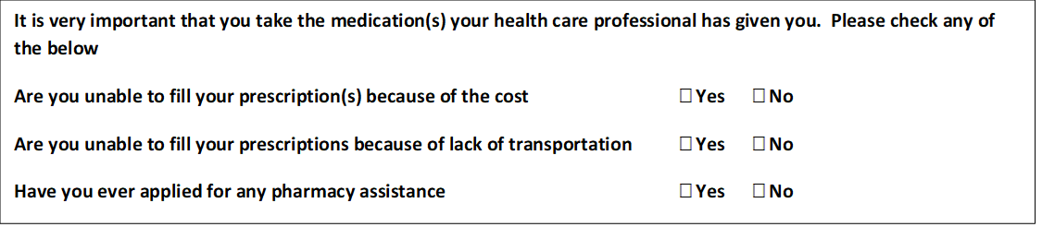

|  |
| --- |
| **Opioid History and Current Usage:** |

**It is very important that you take the medication(s) your health care professional has given you. Please check any of the below**

**Have you ever taken drugs called Opioids Yes No**

**(ex: morphine, oxycontin, dilaudid, fentanyl)?**

**Are you currently taking an Opioid for chronic pain? Yes No**

**Did you utilize non-medication treatments for your pain before taking Yes No**

**medication? (Heat/Cold/Physical Therapy/)**

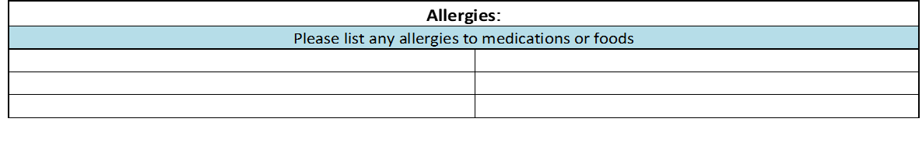

|  |
| --- |
| **Social History: Initial** |
|  |
| **Please circle appropriate answers below and provide explanations where appropriate** |
| **Marital status: 🞏 Single 🞏 Married 🞏 Divorced 🞏 Widowed 🞏 Life Partner** |
| **Education level: 🞏 Did not Graduate 🞏 High School 🞏 Some College 🞏 Bachelor’s Degree 🞏 Master’s Degree or Higher** |
| **Job concerns: 🞏 Stress 🞏 Hazardous substances 🞏 Heavy lifting 🞏 Transportation** |
|  |
| **How stressful would you rate your current living situation: (Circle number)** |
| **Not Very Stressful 0 1 2 3 4 5 6 7 8 9 10 Very Stressful**  **Do you fear for your safety in your current living situation? 🞏 No 🞏 Yes If yes, describe below:** |
| **Are there financial concerns that affect your ability:**  **1) to go to the doctor 🞏 No 🞏 Yes If yes, describe:**    **2) to obtain food and shelter 🞏 No 🞏 Yes If yes, describe:** |
| **Are there any religious or cultural factors that you would like us to take into account when planning your healthcare?** |
| **🞏 No 🞏 Yes If yes, describe:** |
| |  |  |  |  | | --- | --- | --- | --- | | **Current Health Concerns** | | | | | Please check problems or conditions that you are CURRENTLY experiencing | | | | | | € Chest pain | | € Rectal bleeding | € Eye pain | € Nervousness | | € Shortness of breath | | € Black/tarry stools | € Loss of vision | € Pain in testicles | | € Wheezing | | € Weight loss | € Double vision | € Loss of libido | | € Cough | | € Weight gain | € Memory loss | € Impotence | | € Coughing up blood | | € Loss of appetite | € Ringing in ears | € Breast pain | | € Sore throat | | € Difficulty swallowing | € Pain in ears | € Breast discharge | | € Nasal congestion | | € Diarrhea | € Nose bleeds | € Other (please describe below) | | € Irregular heartbeat | | € Constipation | € Hoarseness |  | | € Fast heartbeat | | € Painful urination | € Easy bleeding |  | | € High blood pressure | | € Blood in urine | € Easy bruising |  | | € Low blood pressure | | € Urine frequency | € Rash |  | | € Lightheadedness | | € Decrease in urine flow | € Changes in mole | **Females - Please complete** | | € Dizziness/fainting | | € Urine leakage | € Sore that won’t heal | Menstrual flow: | | € Abdominal pain | | € Headache | € Fatigue/lethargy | € Reg.    € Irreg. € Pain/cramps | | € Heartburn | | € Weakness | € Insomnia | Days of flow __ Length of cycle__ | | € Indigestion | | € Loss of strength | € Forgetfulness | 1st day of last period | | € Ankle swelling | | € Balance problems | € Depression | € Pain or bleeding after sex | | € Nausea | | **Pain, weakness, or numbness in** | | Number of pregnancies | | € Vomiting | | € Arms € Hips € Back | | Miscarriages | | € Vomiting blood | | € Legs € Neck  € Shoulders | | Birth control method | | € Change in bowel habits | | € Hands € Feet | |  |       **Preventive Health Screening**  **🞏 Initial 🞏 Annual**  Name_____________________________________________________ Date Completed ___________________________ | | |  |
| Address______________________________________________________________________________________________ | | | |
| Local phone number____________________________ Alternative phone number__________________ | | |  |
| Preferred Pharmacy____________________________ Pharmacy phone number____________________  Please describe what problem or concern brought you to our office today: | | | |

|  |  |
| --- | --- |
| **Health Literacy Questionnaire:** | |
| **It is really important to your provider that you understand the information related to your health. Please rate the following questions on a scale of 1 to 10; 1 being strongly disagree and 10 being strongly agree** | |
| **I feel that I have a thorough understanding of the instructions**  **that my doctors and nurses give me about my health** | **1 2 3 4 5 6 7 8 9 10** |
| **I feel that I remember the instructions given to me at my doctor’s office when I get home** | **1 2 3 4 5 6 7 8 9 10** |
| **I feel that I have a strong understanding of medical language** | **1 2 3 4 5 6 7 8 9 10** |

|  |  |  |  |  |
| --- | --- | --- | --- | --- |
| **Health Maintenance:** | | | | |
| **Please check whether you have had the following preventive services and enter the year of the service** | | | | |
| **Immunizations** | **Year** |  | **Tests** | **Year** |
| **Tetanus vaccine / Tdap 🞏 Yes 🞏 No** |  | **Pap smear/pelvic 🞏 Yes 🞏 No** |  |
| **Pneumonia vaccine 🞏 Yes 🞏 No** |  | **Mammogram 🞏 Yes 🞏 No** |  |
| **Influenza vaccine 🞏 Yes 🞏 No** |  | **Bone dexascan 🞏 Yes 🞏 No** |  |
| **Shingles vaccine 🞏 Yes 🞏 No** |  | **Colonoscopy 🞏 Yes 🞏 No** |  |
|  |  | **Prostate test 🞏 Yes 🞏 No** |  |
| **Additional Vaccines taken since previous year** | **🞏 Yes** |  | **🞏 No If yes, list vaccine name and date:** |  |

|  |  |
| --- | --- |
| **Health Behaviors: Requires Updating Annually for 11 years and older** | |
|  | |
| **Tobacco use: 🞏 Never 🞏 Quit (when)______________ 🞏 Current smoker** | |
| **If current smoker how many packs per day for how many years___________** | |
| **Alcohol intake: 🞏 No 🞏 Yes If yes how many drinks/how often________________** | |
| **Have you or are you currently taking an Opioid medication smoke 🞏 Yes 🞏 No**  **(ex: morphine, oxycontin, dilaudid, fentanyl)?** | |
| **If yes, Did you utilize non-medication treatments for your smoke 🞏 Yes 🞏 No**  **pain before taking medication? (Heat/Cold/Physical Therapy/)** | |
| **Illicit drug use (including marijuana, cocaine, steroids): 🞏 Never 🞏 Past 🞏 Current** | |
| **If Past or Current drug use describe:** | |
| **Exposure to secondhand smoke 🞏 Yes 🞏 No** | **Wear a seatbelt 🞏 Yes 🞏 No** |
| **Eat a diet high in fruits and vegetables 🞏 Yes 🞏 No** | **See a dentist at least once a year 🞏 Yes 🞏 No** |
| **Get 30 minutes of exercise 5 times a week 🞏 Yes 🞏 No** | **Wear sunscreen 🞏 Yes 🞏 No** |

|  |  |
| --- | --- |
| **Urinary Incontinence Assessment: Requires Updating Annually for 65 years and older** | |
|  | |
| **Do you experience leaking in the following situations: Not at all A little Sometimes A lot** | |
| **During daily activities (work, household task)** | **🞏 🞏 🞏 🞏** |
| **During physical activities (walking, swimming, or other exercise)** | **🞏 🞏 🞏 🞏** |
| **During recreational activities (movies, hobbies)** | **🞏 🞏 🞏 🞏** |
| **During social activities (going out with friends, family visits)** | **🞏 🞏 🞏 🞏** |

|  |  |
| --- | --- |
| **Fall Risk Screening: Requires Updating Annually for 65 years and older** | |
|  | |
| **In the last 12 months have you fallen?** | **🞏 Yes 🞏 No 🞏 Unsure** |
| **If yes, how many times?** | **🞏 1 🞏 2 🞏 3 🞏 4 🞏 5+** |
| **Were you injured as a result of this fall?** | **🞏 Yes 🞏 No 🞏 Unsure** |

|  |  |
| --- | --- |
| **Functional Assessment: Requires Updating Annually for 65 years and older** | |
|  | |
| **Do you need assistance in the following areas?** | |
| **Not at all A little Sometimes A lot** | |
| **Bathing, dressing and grooming** | **🞏 🞏 🞏 🞏** |
| **Daily activities (cooking, cleaning other household tasks)** | **🞏 🞏 🞏 🞏** |
| **Walking or driving** | **🞏 🞏 🞏 🞏** |
| **Communicating needs and feelings** | **🞏 🞏 🞏 🞏** |
| **Understanding directions** | **🞏 🞏 🞏 🞏** |
| **Keeping appointments, taking medications and performing other medical treatments** | **🞏 🞏 🞏 🞏** |
| **If yes to any of these questions, who helps with these activities?** |  |

|  |  |
| --- | --- |
| **Mood Screening: Requires Updating Annually for age 11 and up** | |
| **A person’s mood can have a strong influence on their health status and overall wellbeing.**  **Over the past 2 weeks, how often have you been bothered by any of the following problems?** | |
| **Little interest or pleasure in doing things** | **Feeling down, depressed, or hopeless** |
| **🞏 Not at all** | **🞏 Not at all** |
| **🞏 Several days** | **🞏 Several days** |
| **🞏 More than half the days** | **🞏 More than half the days** |
| **🞏 Nearly every day** | **🞏 Nearly every day** |
|  |  |
| **Social History: Requires Updating Annually** | |
| **Please circle appropriate answers below and provide explanations where appropriate** | |
| **Job concerns: 🞏 Stress 🞏 Hazardous substances 🞏 Heavy lifting 🞏 Transportation**    **Have you had CHANGE in Marital Status: 🞏 No 🞏 Yes If yes, describe below:**  **How stressful would you rate your current living situation?** | |
| **Not Very Stressful**  **0 1 2 3 4 5 6 7 8 9 10** **Very Stressful** | |
| **Do you fear for your safety in your current living situation? 🞏 No 🞏 Yes If yes, describe below:** | |
| **Are there financial concerns that affect your ability:**  **1) to go to the doctor 🞏 No 🞏 Yes If yes, describe:**    **2) to obtain food and shelter 🞏 No 🞏 Yes If yes, describe:** | |
| **Are there any religious or cultural factors that you would like us to take into account when planning your healthcare? 🞏 No 🞏 Yes If yes, describe:** | |

Patient Signature:__________________________________________________ Date:______________________________

Provider reviewed:_____________________________________________­­____ Date:_______________________________